Aim:
- Node JS Modules
- Node Package Manager
- Creating Web server
- File System
- Node JS Module
In Node.js, Modules are the blocks of encapsulated code that communicates with an external application on the basis of their related functionality. Modules can be a single file or a collection of multiples files/folders. The reason programmers are heavily reliant on modules is because of their re-usability as well as the ability to break down a complex piece of code into manageable chunks.

Modules:
Core Modules local Modules
Core Modules: Node.js has many built-in modules that are part of the platform and comes with Node.js installation. These modules can be loaded into the program by using the require function.
Syntax:
let os = require('os') console.log(os.arch()) console.log(os.platform()) console.log(os.userInfo())
console.log(os.totalmem())
Output:
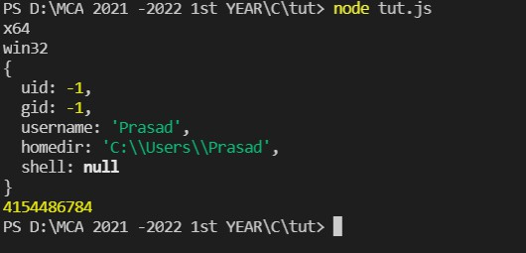
Local Modules: Unlike built-in and external modules, local modules are created locally in your Node.js application. Let’s create a simple calculating module that calculates various operations.

- Node package Manager(NPM)
NPM (Node Package Manager) is the default package manager for Node.js and is written entirely in Javascript. Developed by Isaac Z. Schlueter, it was initially released in January 12, 2010. NPM manages all the packages and modules for Node.js and consists of command line client npm. It gets installed into the system with installation of Node.js. The required packages and modules in Node project are installed using NPM.
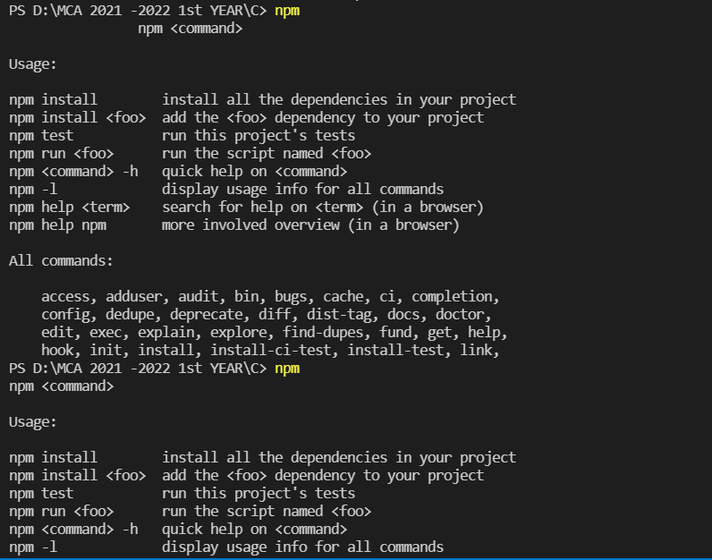
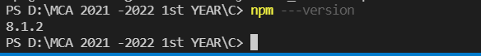

Installing package “express”

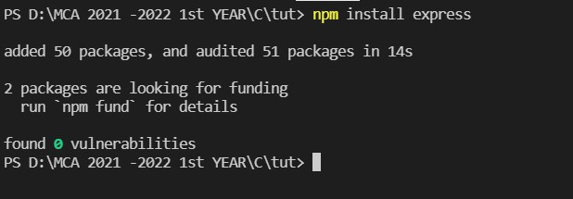
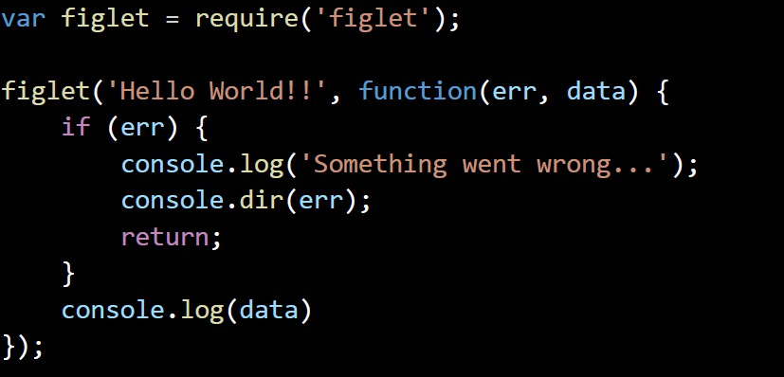


- Creating Web server: Syntax:
var http=require("http") http.createServer(function(req, res){
res.writeHead(200, {'Content-Type': 'text/html'}); res.write("Hello node");
res.end();
}).listen(3000);
Output:



- File System:
Syntax:
const fs = require("fs");
let text = fs.readFileSync("read.txt", "utf-8"); text = text.replace("application", "file")

console.log("The content of the file is") console.log(text);

console.log("Creating a new file..") fs.writeFileSync("Prasad.text", text)

Output:
